Bandit Level 7
DG Interns Hub | Week 1 | OverTheWire Bandit Writeup

Objective
Search across the system for a file with specific ownership and size.

Activity summary
Suggested learning command / approach: find / -user bandit7 -group bandit6 -size 33c 2>/dev/null. Use only on the authorized OverTheWire training environment.

Key learning
Searching by ownership and size.

Evidence
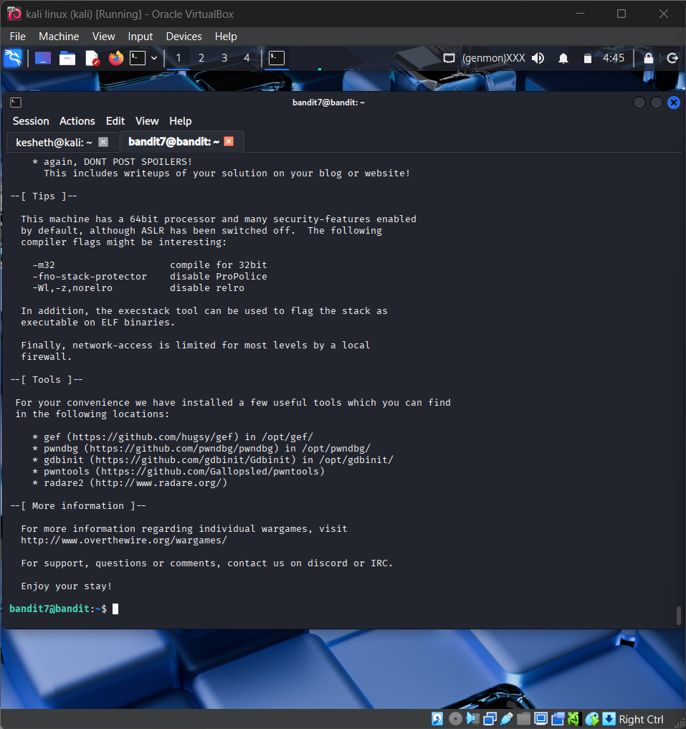
Screenshot: Bandit_Level_7.png
The screenshot is evidence of level activity/login; it may not show every solution step. No passwords are reproduced.

